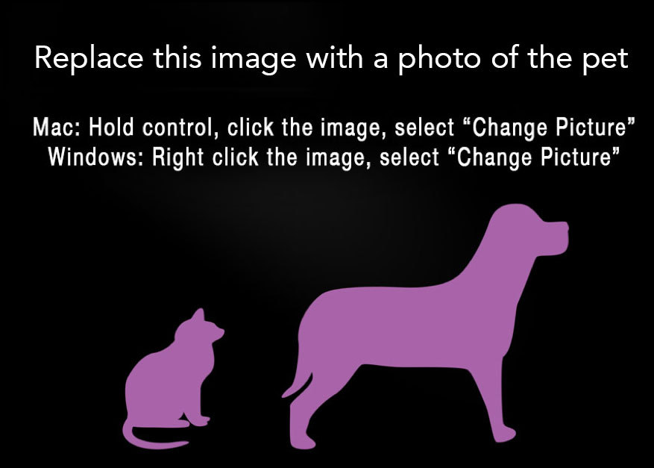
FOUND CAT/DOG

Breed and Color
LOCATION FOUND: Date and Location
Other Identifiable Information, Distinguishing Features

PLEASE CALL:
XXX-XXX-XXXX
FOUND CAT/DOG
FOUND CAT/DOG

Breed and Color
LOCATION FOUND: Date and Location
Other Identifiable Information, Distinguishing Features

PLEASE CALL:
XXX-XXX-XXXX
FOUND CAT/DOG

FOUND CAT/DOG

Breed and Color
LOCATION FOUND: Date and Location
Other Identifiable Information, Distinguishing Features

PLEASE CALL:
XXX-XXX-XXXX
FOUND CAT/DOG

